**DCN Lab-Fat Prashanth.S   
 (19MID0020)**

**Question-1**

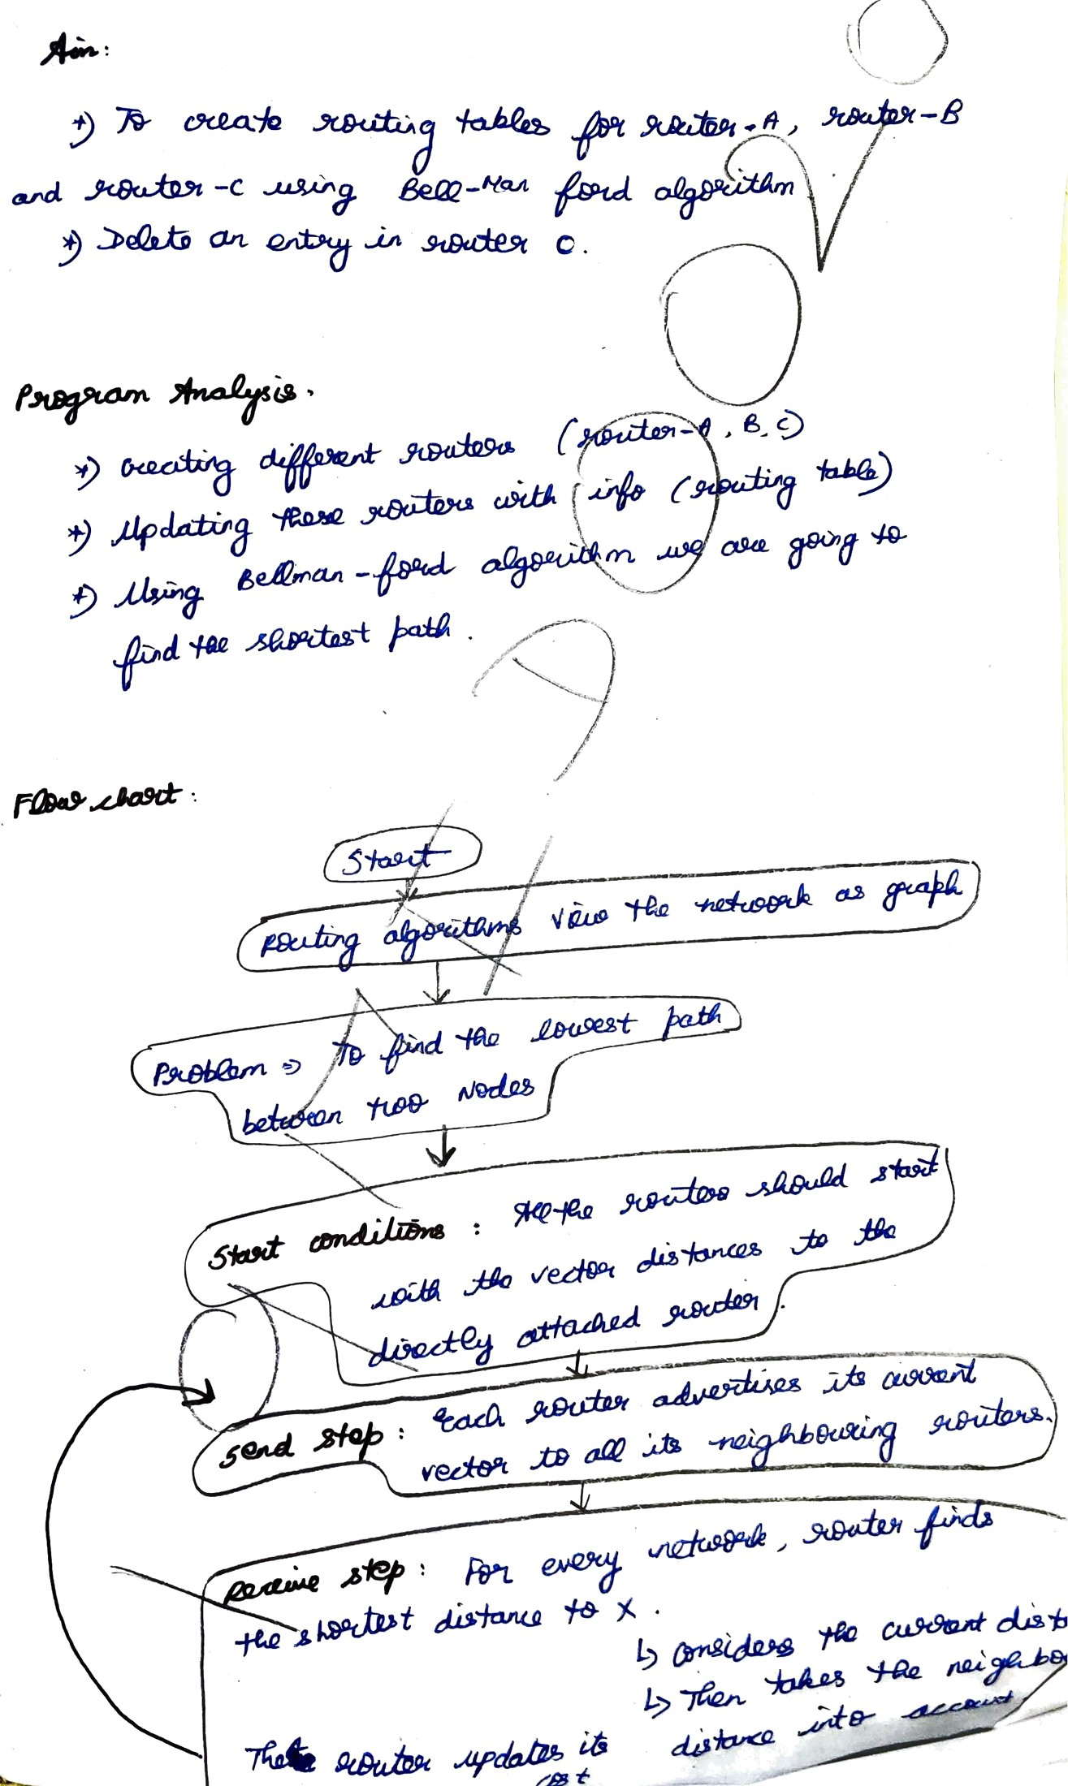

**Code Snippet**

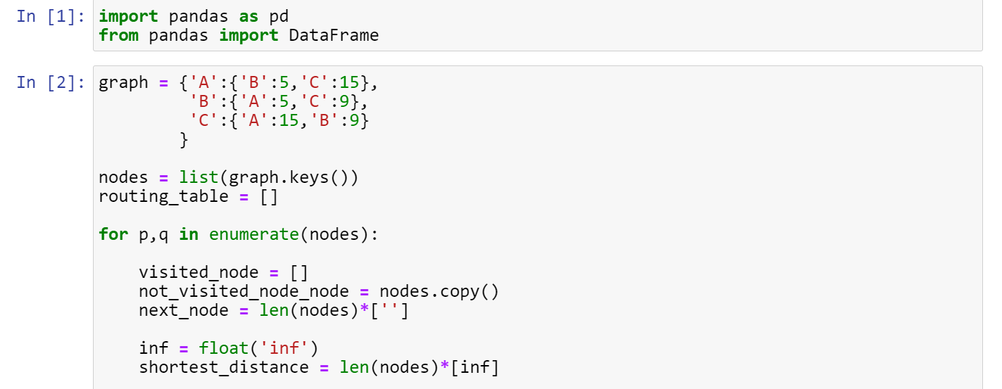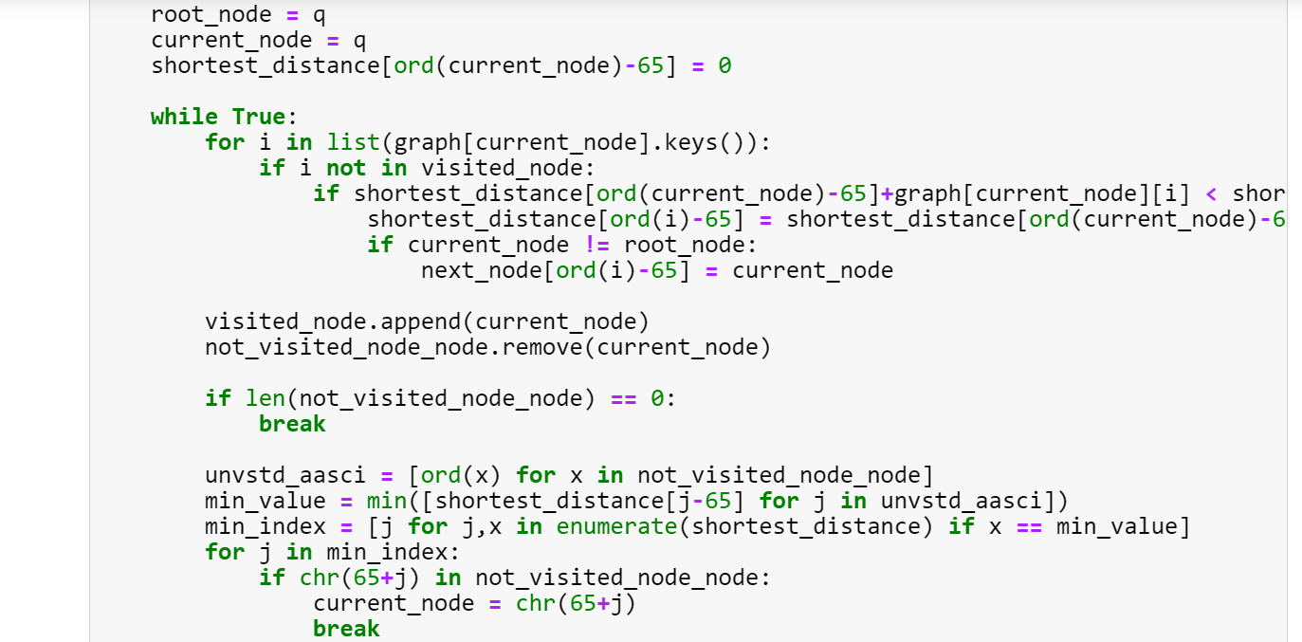

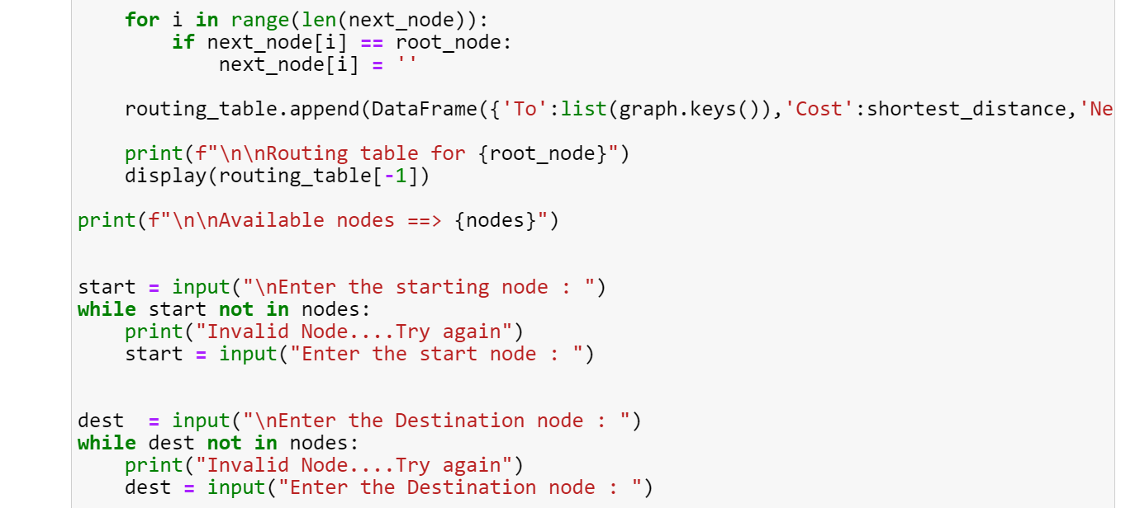

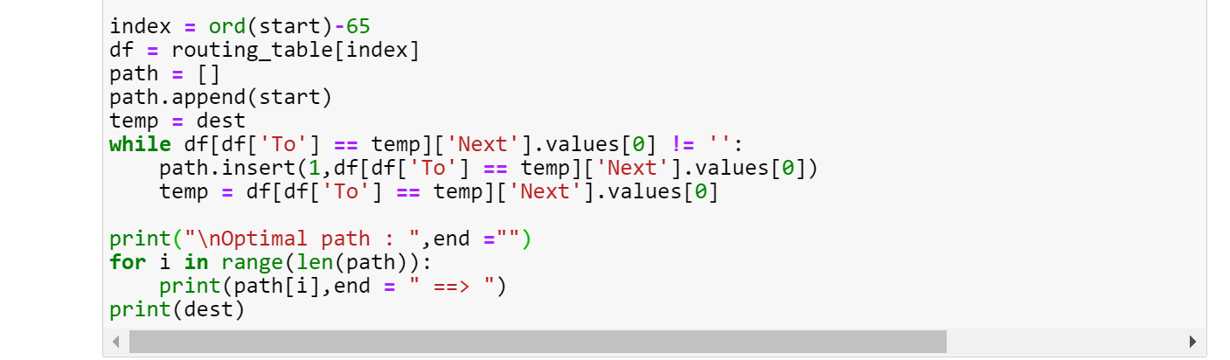

**Test-case 1**

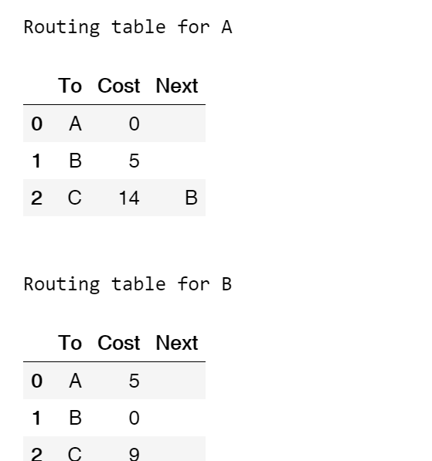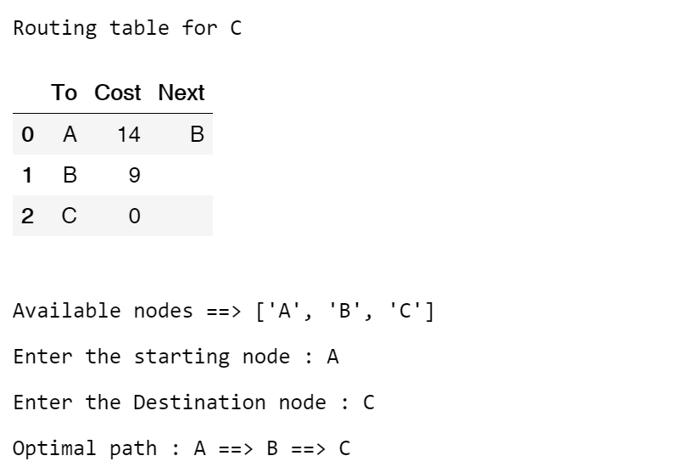

**Test-case 2**

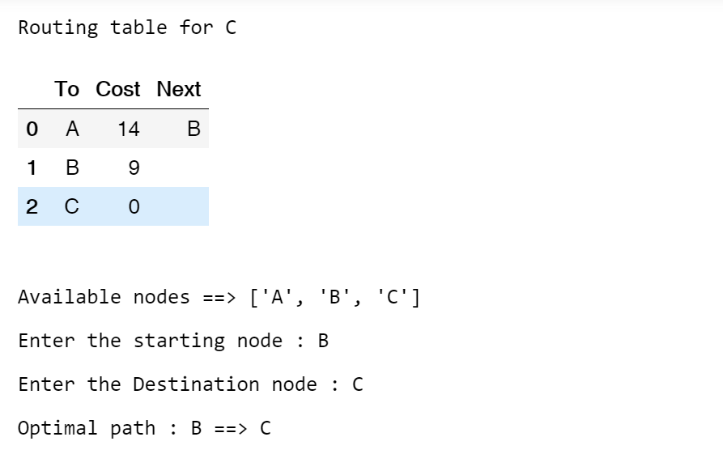

**Output**

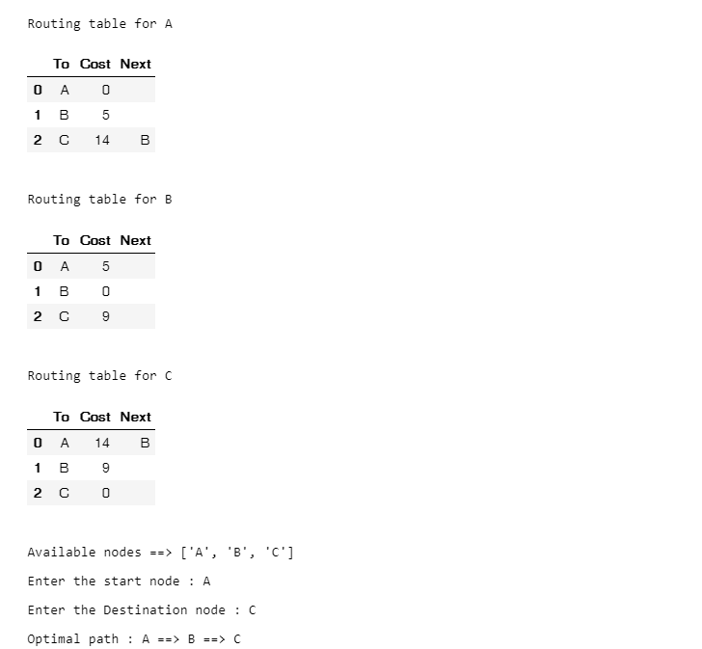

**Actual Code**

import pandas as pd

from pandas import DataFrame

graph = {'A': {'B': 5, 'C': 15},

'B': {'A': 5, 'C': 9},

'C': {'A': 15, 'B': 9}

}

nodes = list(graph.keys())

routing_table = []

for p, q in enumerate(nodes):

visited_node = []

not_visited_node_node = nodes.copy()

next_node = len(nodes) * ['']

inf = float('inf')

shortest_distance = len(nodes) * [inf]

root_node = q

current_node = q

shortest_distance[ord(current_node) - 65] = 0

while True:

for i in list(graph[current_node].keys()):

if i not in visited_node:

if shortest_distance[ord(current_node) - 65] + graph[current_node][i] < shortest_distance[ord(i) - 65]:

shortest_distance[ord(

i) - 65] = shortest_distance[ord(current_node) - 65] + graph[current_node][i]

if current_node != root_node:

next_node[ord(i) - 65] = current_node

visited_node.append(current_node)

not_visited_node_node.remove(current_node)

if len(not_visited_node_node) == 0:

break

unvstd_aasci = [ord(x) for x in not_visited_node_node]

min_value = min([shortest_distance[j - 65] for j in unvstd_aasci])

min_index = [j for j, x in enumerate(

shortest_distance) if x == min_value]

for j in min_index:

if chr(65 + j) in not_visited_node_node:

current_node = chr(65 + j)

break

for i in range(len(next_node)):

if next_node[i] == root_node:

next_node[i] = ''

routing_table.append(DataFrame(

{'To': list(graph.keys()), 'Cost': shortest_distance, 'Next': next_node}))

print(f"\n\nRouting table for {root_node}")

display(routing_table[-1])

print(f"\n\nAvailable nodes ==> {nodes}")

start = input("\nEnter the starting node : ")

while start not in nodes:

print("Invalid Node....Try again")

start = input("Enter the start node : ")

dest = input("\nEnter the Destination node : ")

while dest not in nodes:

print("Invalid Node....Try again")

dest = input("Enter the Destination node : ")

index = ord(start) - 65

df = routing_table[index]

path = []

path.append(start)

temp = dest

while df[df['To'] == temp]['Next'].values[0] != '':

path.insert(1, df[df['To'] == temp]['Next'].values[0])

temp = df[df['To'] == temp]['Next'].values[0]

print("\nOptimal path : ", end="")

for i in range(len(path)):

print(path[i], end=" ==> ")

print(dest)

**Question-2**

